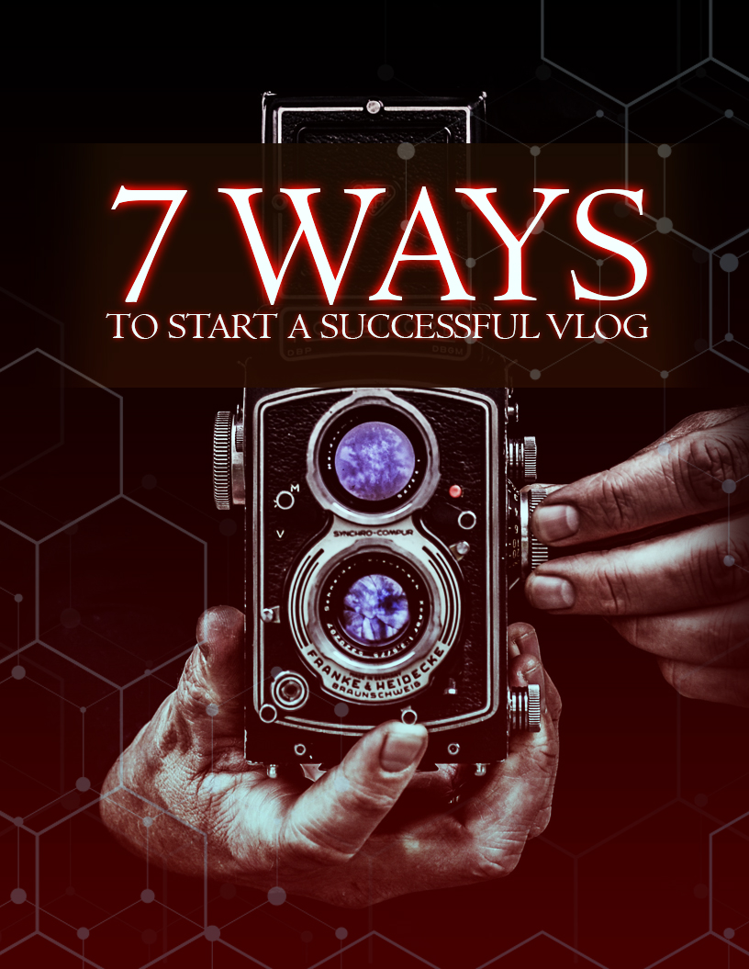

Limited Special Offer
Modern Vlogging
Full Training
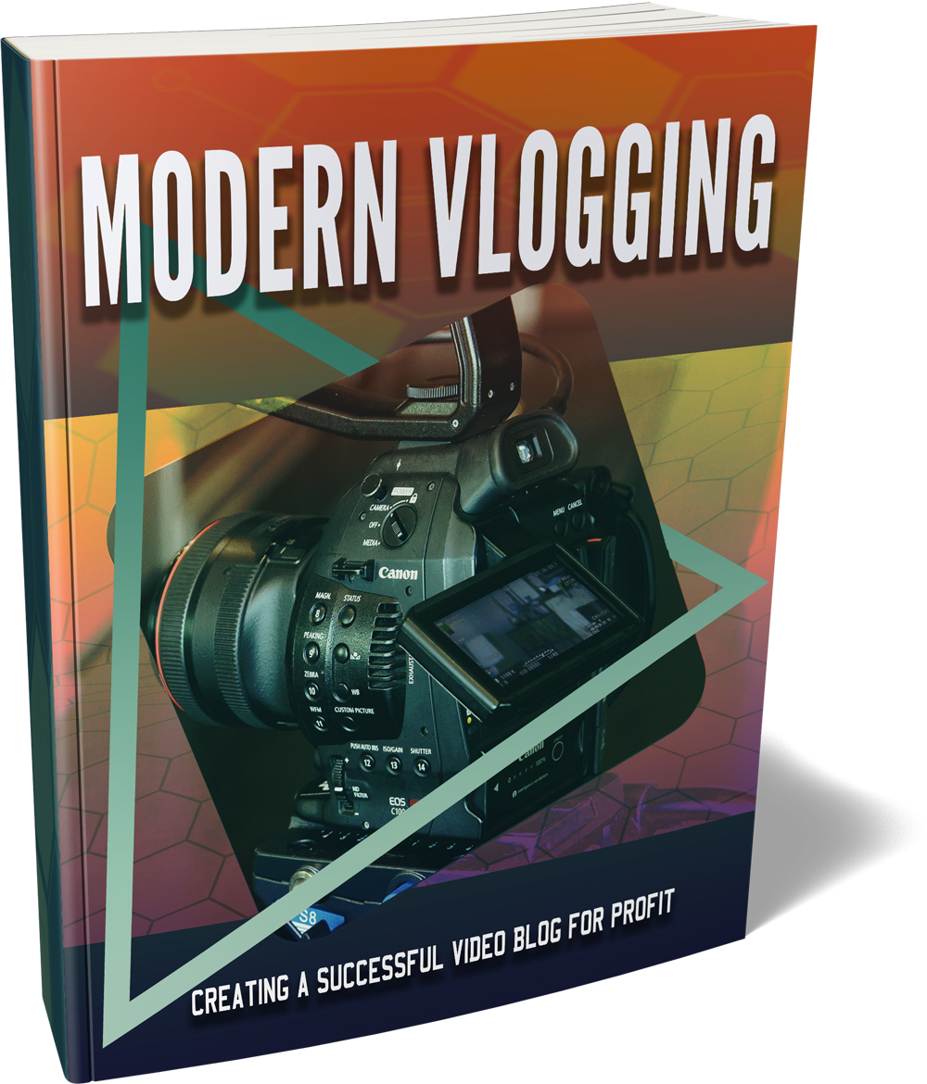

Click Here to Download the Full Training!
(Insert your Front End Offer URL)


Why should you start a Vlog?

People are curious by nature and they like to see what other people are doing with their lives. This is the reason why reality TV is so successful. What are the ordinary people doing out there? What are their hopes and dreams? What excites them and how do they go about their day?
It doesn’t matter that someone doesn’t know you. You have a message to share with the world and a vlog is the perfect way to do it. Sure you could create a conventional blog and write posts about your life and share your experiences. But people prefer video.
In a survey conducted by HubSpot a while ago, they discovered that 72% of participants preferred to watch video rather than read a blog post to learn how to do something or find out more about a product or a service.
YouTube is a giant of a website. There are 1 billion users who consume hours of video every day. There will always be somebody searching YouTube for what you are good at. This provides you with a fantastic opportunity.
With a vlog you can create a real connection with your viewers. It is different to creating a one off video. If you provide quality videos (and you must) then people will eagerly await the next one that you upload.
There are many vlogging success stories. These are ordinary people who drastically changed their lives through vlogging. They have all kinds of sponsorship deals and several different revenue streams. Some vloggers became millionaires very quickly – there is no reason why you cannot be the next vlogging sensation.
In this short report we will provide you with the 7 ways to start a successful vlog. How you start your vlog is really important. If you don’t get off to a flying start then it will be a real struggle for you. Use the methods in this report and you won’t go wrong.



The most successful vlogs are always planned. The vlog owner has thought through what they want to achieve with their vlog and put a plan of action in place. You must do the same. The starting point is to define the goal of your vlog.
This is something that you can easily do in a short time. Start right now and have the goal of your vlog defined in a few hours. Don’t spend too much time on this. Some people will spend weeks planning something and then it never happens.
What are you going to communicate with your vlog? You need to vlog about something that you can get excited about. Remember that you want to make a profit from your vlog so you need to think about how you will do this.
So start off by writing a list of all the things that interest you. Here are some good ideas for vlogs:
- Travelling the world
- Making money online
- Beauty and makeup
- Owning a pet
- Sports fan vlogs
- Learning specific skills
- Getting the girl/boy
The main reason that all of these ideas are good is because there is so much scope for creating videos here. The other good reason is that these kinds of vlogs are pretty easy to monetize. And that’s good news isn’t it?
Go to YouTube and have a look at what other people are vlogging about. This should give you even more inspiration. Don’t worry that there are a lot of other players in the same niche. Competition is a good thing. It proves that there is an audience out there.
Your personality is very different to the other people making the vlogs in your niche. This will make you stand out. It would be more of a concern if there were not vlogs already out there in the niche you were interested in.



OK so you have chosen an idea for your vlog. Now it is time to see the size of the market and what type of audience your vlog will appeal to. This is a very important exercise. Checking that there are other vlogs in your niche is a good first step but it is not enough.
The first thing you need to do is some keyword research. You need to find out what terms people are using to find videos in your niche and how often they are looking (search volume). You can do this for free by using the Google Keyword Planner.
To access the Google Keyword Planner you will need a free Google account (such as a gmail email address) and you will need to open a free Google Adwords account – don’t worry you are not going to spend any money!
Once you are in the Google Keyword Planner enter a main keyword for your niche. As an example we will use “makeup”. There are hundreds of thousands of searches each month on Google for this term. The Google Keyword Planner also came up with a lot of other great related terms such as:
- Eye makeup
- Makeup set
- Makeup kit
- Makeup brands
- Cheap makeup
- Primer makeup
- Face makeup
And there were a lot more keyword suggestions. These are all great ideas for videos. Every one of these terms are searched for thousands of times a month. OK this is for Google, but the same terms are going to be used in the search box on YouTube.
There are two things to bear in mind here:
- The search volume
- The different related keyword terms
The search volume confirms there is a demand for information around the specific keywords. A lot of people want to know about “eye makeup” for example. The related keywords show you the scope of the niche. There are so many different topics that you can create videos about. This is a very good niche for a vlog.
What about your audience? If you want to have a successful vlog then you need to focus on your target audience. This starts by knowing who your target audience is. What are their interests? What are the gender and age demographics? What kind of videos do they like? Where do they come from?
When you know the answers to all of these questions you can fine tune your videos so that they meet all of the requirements of your target audience. It is no use just guessing and creating any kind of video. There is a high probability that you will get it wrong.
Find out what questions your target market are asking. Do they want tutorials on how to use eye makeup to the best effect? Do they want to know what the best makeup products are? Are they looking for the best budget makeup?
Your vlog needs to answer the questions that your target market has. When you are able to do this your vlog will be successful. It’s simple really – give people what they want and they will come back for more and tell the world about it.



Nobody is going to expect you to create Hollywood style videos but they will expect quality. OK you could get away with recording your vlog videos on your smartphone. The cameras and microphones in today’s smartphones are pretty good, but if you are serious about your vlog, and you must be, then there are better tools available.
Your viewers will expect your video to be clear and sharp. HD video quality is easy to create these days with inexpensive cameras. You don’t need the latest Sony professional camera costing thousands of dollars. To start with you can get a camera that shoots 720p HD for under $100.
If you are going to shoot a lot of outdoor footage then a good solution is the GoPro Hero. This is real quality at a good price. By making an investment in a good camera you will be more committed to your vlog which is a good thing.
Next is audio. A video that has poor audio quality is never well received. Some people will create tutorial videos on their laptops and then use the internal laptop microphone. These are usually really poor quality - so don’t do this. Invest in a good quality microphone to ensure audio is clear.
What about software? Well you will need a video editing suite whatever kind of videos you create. If you are going to provide tutorials (always good) then you will probably want to record your computer desktop.
Let’s start with video editing. It is very unlikely that you will shoot a perfect video the first time around so you will need to cut stuff out and add some refinements to make your videos really look professional.
You can do this for free by using Windows Movie Maker for Windows computers or iMovie for Mac computers. Both of these video editing programs have all that you need to make really professional videos. There are other video editing suites that cost a lot of money but you don’t need these to get started.
For recording your computer desktop then Camtasia is the best choice. It works on Windows and Mac computers and costs around $200. There is a free trial so you can test it out first. If you are on a budget then CamStudio is a free alternative that will do most of the basic things for Windows users. There are free applications for Mac users available too.
Video quality is everything so don’t be afraid to invest a few dollars into your vlog. It will definitely pay you back in the long run. Poor quality videos just don’t cut it and you will not get many channel subscribers which is the opposite of what you want.



OK the first thing to say here is that there is no better platform to use for your vlog than YouTube. At the time of writing this report it is the second most visited website on the planet just behind Google and just ahead of Facebook. Every day YouTube gets around 4 billion views!
The first step to creating your YouTube channel is to decide on a name for your vlog. This will be your brand. Some people use their own name which is fine. But if you don’t want to do that then you need to get creative and think of a memorable name. Then you need to check that nobody else has a channel with this name.
With your channel name decided you need to create it. You will need a Google account to setup a YouTube account if you don’t have one already. Login to your YouTube account and create your channel (there are plenty of videos on YouTube to show you how to do this).
To be taken seriously you need some good channel art. Don’t worry you don’t have to be a graphic designer to do this. Don’t spend a lot of time trying to do this yourself. Head over to Fiverr.com and find a good designer that will create your YouTube channel art for a few dollars.
Once your YouTube channel has been established for more than 30 days and you have some videos uploaded and more than 100 subscribers then apply for a custom channel URL. This is very important for your marketing.



This is essential. It is not about quantity it is about quality. If people like your video (which is what you want) then they will expect you to upload new videos regularly. We will discuss this more later.
Unless you are confident to sit in front of a camera and record videos on the fly it is best to create a video script and storyboard. This will take a bit of effort but it is really worth doing. You don’t have to write every word down that you are going to say in your video script. Just add pointers and “lead ins” so that you can discuss each aspect of the video.
If you are going to create a tutorial then plan the footage you will need. Are you going to demonstrate how to do something live or do you need to record your computer screen to show “over the shoulder” how to do something? Both of these are fine but you need a plan.
Once you have your video plan and script done then create a storyboard. What happens first and then all the segments right to the end. It is vital that your videos start well and end well. A great start will compel viewers to keep on watching. A great ending will leave them wanting more videos from you.
When you are recording make sure that you are passionate and excited. If you are not passionate about your videos then how can you expect your viewers to be excited to watch them? Don’t resort to a monotone delivery – people don’t want this. If you need to work on your skills here then do it.
Be sure to appeal to the viewer’s emotions as much as possible. Make them excited by telling them that they will get fantastic results. Use as many superlatives as you can without overdoing it. Tell them that they will look beautiful if they follow your makeup tips for example.
With all of your videos ask the viewers to subscribe to your channel and like the video. Think about how you want to end each video. What do you want the viewer to do (if anything) when they have finished watching?
Do you want them to visit your website and subscribe to your email list for other “insider tips and secrets?” Do you want them to buy something? Use a good call to action at the end. Tell them to do this halfway through the video as well just in case they don’t watch your video all the way through.
Don’t overdo this. Provide them with value as a priority. Just mention that you have a newsletter with other great tips that they can only get by being an email subscriber for example. You are not trying to sell a used car!
Always encourage interaction in your videos. Tell your viewers that you would love to receive their comments about the video as your aim is to provide them with what they want. When you receive comments always respond to them as fast as you can.
So how often should you create new videos for your vlog? Well this is really up to you but we would recommend that you upload new videos at least once every 2 weeks. If you leave too much time between posting videos people will forget about your vlog and go somewhere else.



Many YouTube videos that are optimized properly appear on the first page of Google for related search terms. This is awesome! There are no guarantees here but at the very least you want your videos to appear in the YouTube search results when people search there (which a lot will).
Earlier on in this report we recommended that you conduct keyword research for your vlog. We also recommend that you do this for all of your videos. So if you are going to make a video about “eye makeup” then input that into the Google Keyword Planner and see what related terms come up. Create a list of around 5-10 good keywords per video.
The most important part of YouTube video optimization is your video title. Create an appealing title that people will want to click on. Include your main keyword in the title as well. So for your eye makeup video you could use:
Stunning Eye Makeup Tips For The Most Beautiful Eyes
Brainstorm a few different titles with the main keyword “eye makeup” in them. Then choose the one that appeals the most. Don’t just use your main keyword as the title e.g. Eye Makeup. This is boring and you want to add more persuasive words to get the click.
Next write a description for your video. If you are going to add an external link to your website for example then add this first so that it appears above the fold. Your description needs to describe what your video is all about so think benefits here. Naturally include a few of your keywords too.
The last step is your video tags. Don’t go crazy with this. Add around 5-8 tags from your keyword list including your main keyword. At the time of writing there is a 400 character limit on tags. Don’t think that you have to use all of these characters because you don’t.
One final thing here is your video thumbnail. This doesn’t really impact your optimization but a good thumbnail will always get the click over a poor one. Some people design specific thumbnails for each video. Whatever you do make your thumbnails really stand out.



Don’t just rely on YouTube search traffic for views to your vlog videos. Do everything that you can to get the word out to people that your new vlog has arrived. Tell everyone that you know about your vlog.
Use social media to make posts about your vlog. Facebook, Twitter and Instagram are all good platforms to promote videos. There are other social sites such as Reddit.com and Quora.com which you can use to promote your vlog. Take advantage of all of these platforms.
Don’t believe in the “build it and they will come” philosophy. Yes you will get some views to your videos and some subscribers just from YouTube search traffic. But this will never be enough to really make your vlog take off.
The name of the game is to increase the number of subscribers that your YouTube channel has. Focus on this rather than the money you can make. When you achieve high subscriber numbers the money will naturally follow.



You need to be totally committed to your vlog if you want it to be a success. Consistency is very important. You need to make high quality videos on a consistent basis and be consistent with your video uploading and the promotion of your vlog.
It is going to take time for you to reach a high number of subscribers but if you stick at it then this will come. High subscriber numbers will open doors for you with sponsorships and other money making opportunities.
So follow the 7 ways to start a great vlog in this report and you won’t go wrong. If you don’t have the right recording equipment then get it. You must avoid uploading poor quality videos. Good luck with your vlog and your rise to fame on YouTube!

