Chapter 4: Develop Your Skills


S1: In this video, we’ll learn how to “Develop Your Skills”

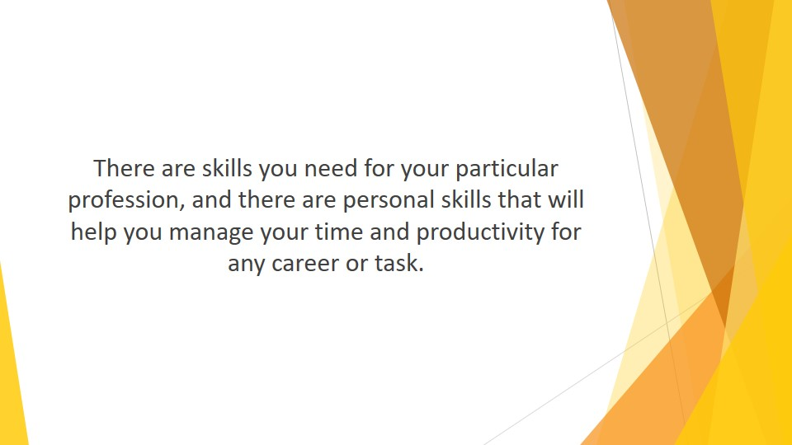
S2 : There are skills you need for your particular profession, and there are personal skills that will help you manage your time and productivity for any career or task.

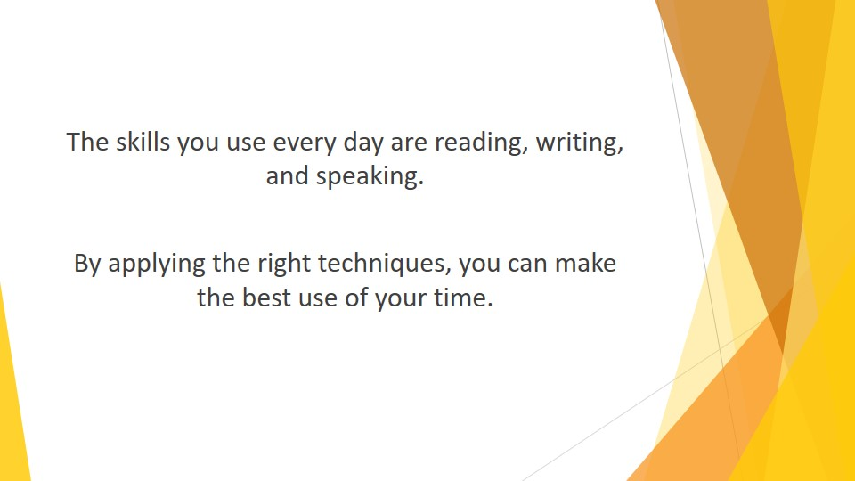
S3 : The skills you use every day are reading, writing, and speaking. You learned all that in school, and you probably don’t even think about how you approach these skills. However, by applying the right techniques, you can make the best use of your time.

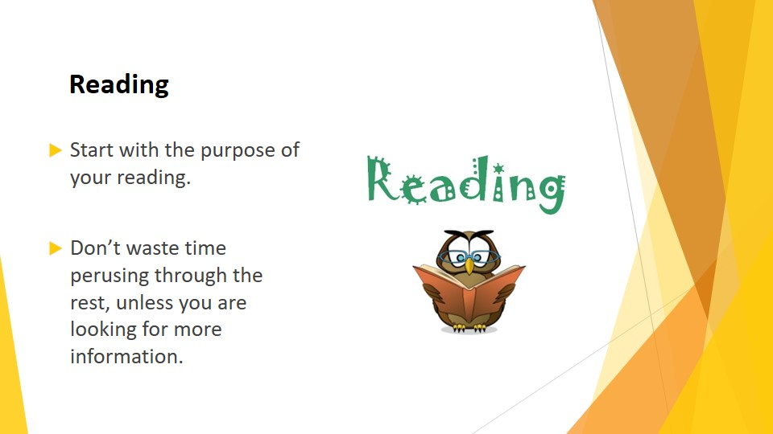
S4 : Reading
Reading is easy, right? It is, but you need to read a specific way if you are managing your time.
Start with the purpose of your reading. Are you reading for enjoyment, or are you trying to garner information? You probably have different mediums for different needs. You might have one paper for sports, another for editorials, and a magazine for industry/professional information. If that is the case, don’t waste time perusing through the rest, unless you are looking for more information.

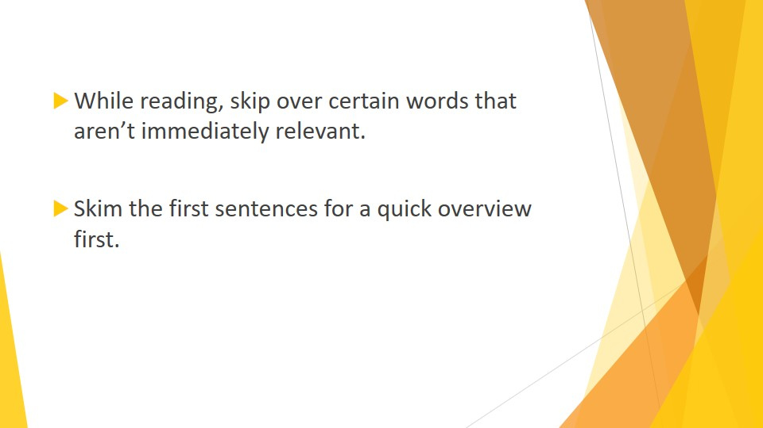
S5 : While reading, skip over certain words that aren’t immediately relevant. You want the gist of what is being said. Read the headings to determine whether the information is pertinent. If not, move on to the next article.
Read the beginning and conclusion of any article first. This will tell you whether the midsection is worth reading. Don’t waste your time if it isn’t.
Remember that the first sentences of paragraphs are usually lead-ins and can safely be skipped for the full information that follows. The opposite will apply if you are unsure if the article has any relevant information that you might need. Skim the first sentences for a quick overview first.

When reading a long article, make a few notes on pertinent important points. This will help organize the information in your mind.

Does this sound like sloppy information-gathering? It isn’t. You are trying to determine how much time you should spend on a particular article or book. Once you have a clear idea, you can gather all the information you need and read as much as is necessary. This will save you much wasted reading time as opposed to “properly” reading every word and then picking out the salient points. For better time management, do it the other way around.

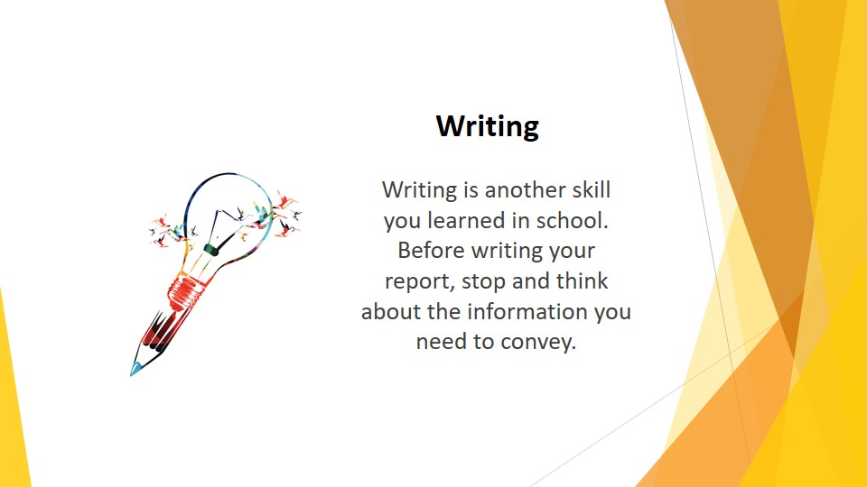
S6 : Writing
Writing is another skill you learned in school. Unfortunately, few of us are taught to write clearly and concisely. In addition, the use of emails and text have largely eroded what little writing skills are left.
Before writing your report, stop and think about the information you need to convey.

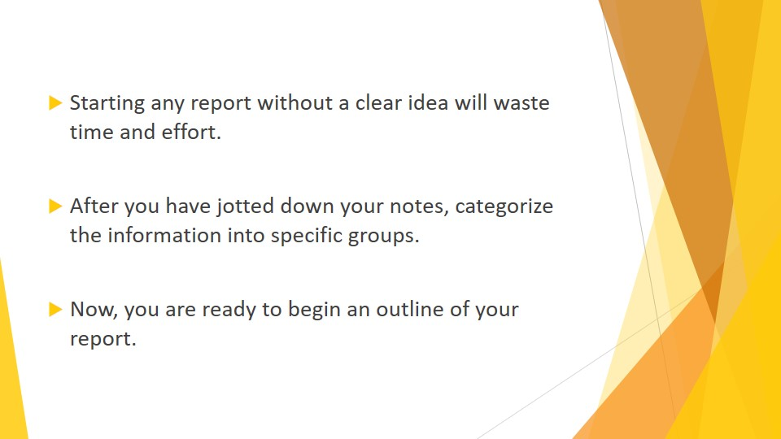
S7 : Brainstorm and jot down ideas as they come. This will be the beginning of a roadmap that will tell you where you are going and where you need to go to get there. Starting any report without a clear idea will waste time and effort.
After you have jotted down your notes, categorize the information into specific groups. For example, you may wish to categorize a company report into financial information, product information, sales data, departmental responsibility, etc.
Now, you are ready to begin an outline of your report. Before beginning your outline, consider your audience. What information requires the most persuasion? For example, a group of investors will likely be most interested in bottom line financials. A meeting with new employees might need more product information and company structure data.

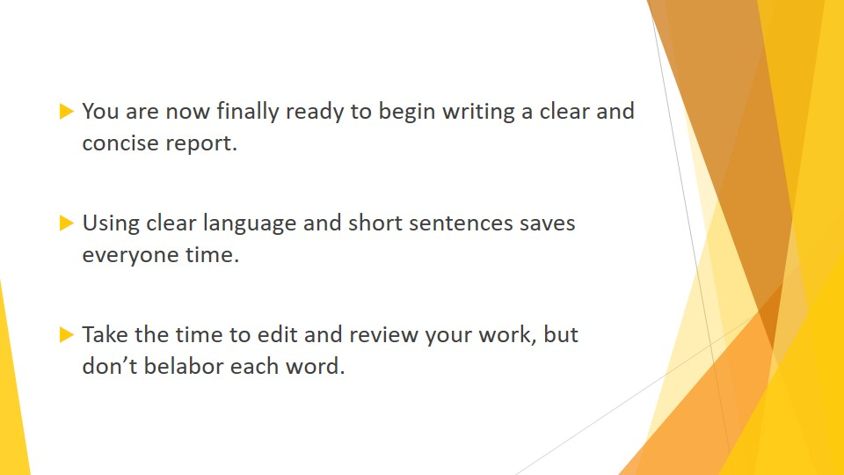
S8 : You are now finally ready to begin writing a clear and concise report. Start with an introduction, move on to the main theme, and wrap it up with a conclusion.
Using headings and lead-in sentences can help clarify the information, as has been indicated in the “Reading” section. It can also help keep you organized.
Try to keep industry jargon at a minimal. Have you ever read a manual, only to wonder whether you are reading Latin? Using clear language and short sentences saves everyone time.
Take the time to edit and review your work, but don’t belabor each word. Such per-fectionist tendencies will force you to take twice the time necessary to complete your work.


S9 : Speaking
When you started speaking, your parents no doubt thought you were a genius. Public speaking is a bit more complicated.
Like writing, speaking starts with knowing your audience. Who will be there, and what is their purpose? With what information do your listeners hope to walk away?
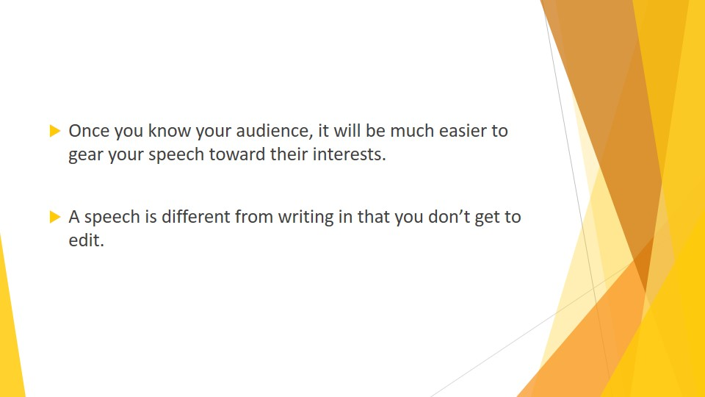
S10 : Once you know your audience, it will be much easier to gear your speech toward their interests.
A speech is different from writing in that you don’t get to edit. Your first try is your only chance. But don’t be overly concerned about perfection. It’s a real time waster.

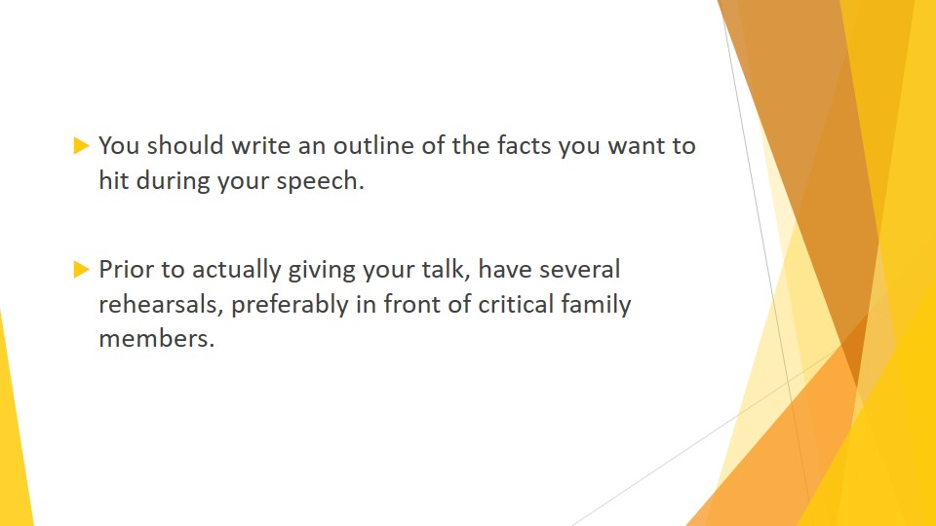
S11 : You should write an outline of the facts you want to hit during your speech. After your introduction, whet your audience’s appetite by explaining why your information is relevant to them. How can it help them? Then, tell give them a few verbal “headings” by telling them what you will be talking about, as in, “here is a problem,” “here are my thoughts on the problem,” and “here’s how we can solve the problem.”
Prior to actually giving your talk, have several rehearsals, preferably in front of critical family members. You want to be speaking out loud to help you get the tempo and inflections.

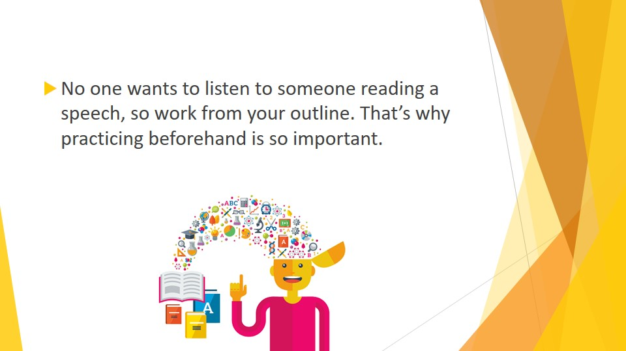
S12 : No one wants to listen to someone reading a speech, so work from your outline. That’s why practicing beforehand is so important.

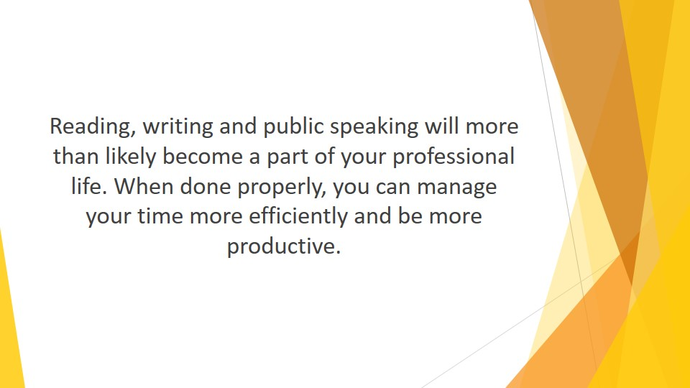
S13 : Reading, writing and public speaking will more than likely become a part of your professional life. When done properly, you can manage your time more efficiently and be more productive.

