Introduction


S1: Pause for 2 seconds


S2: If you are watching this video, you are undoubtedly trying to become more productive by managing your time better. That’s a great goal. But you can’t really manage time.

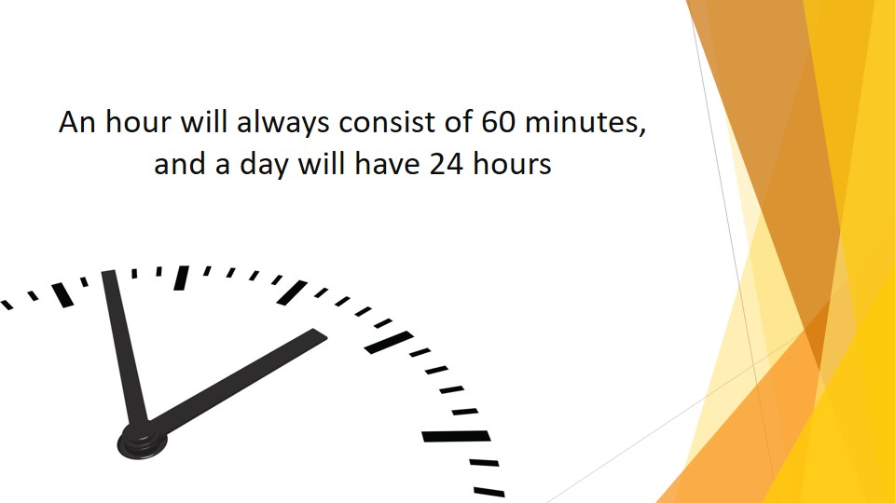
S3: An hour will always consist of 60 minutes, and a day will have 24 hours. That can’t be changed.

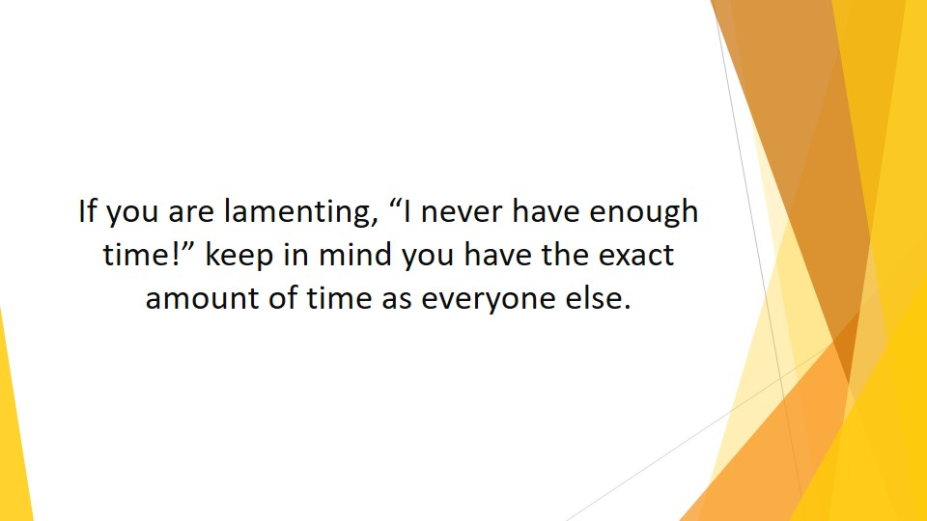

S4: So, if you are lamenting, “I never have enough time!” keep in mind you have the exact amount of time as everyone else.

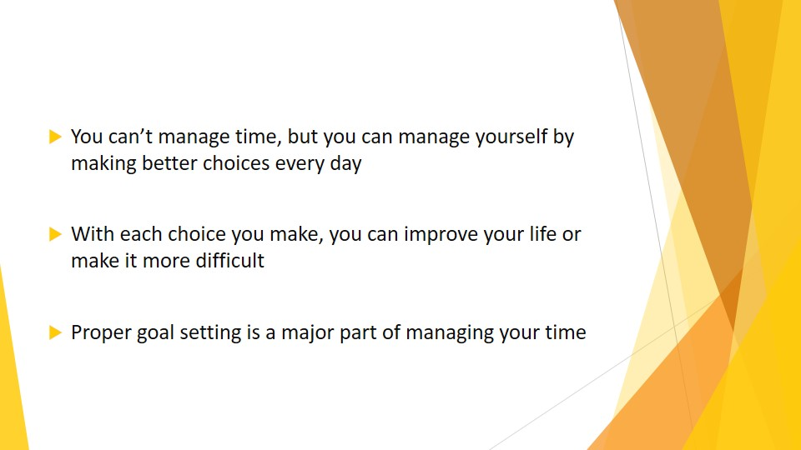
S5: You can’t manage time, but you can manage yourself by making better choices every day. With each choice you make, you can improve your life or make it more difficult.
Proper goal setting is a major part of managing your time. However, it’s critical not to confuse your end goal (the final result) with the steps designed to get you there.

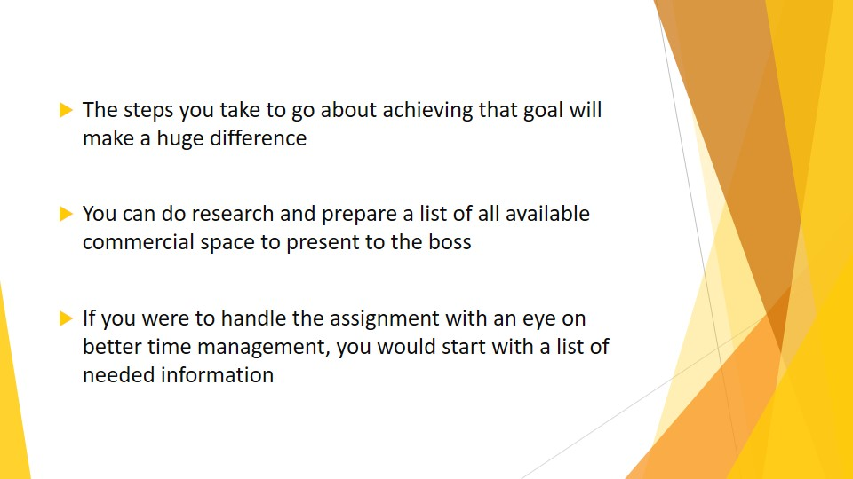
S6: For example, let’s say your boss has placed you in charge of finding new office space. That’s the end goal. But the steps you take to go about achieving that goal will make a huge difference.

You can do research and prepare a list of all available commercial space to present to the boss. This will probably take a few days. And you’re not even close to the end goal, which is finding a new office for your particular company. You’ve started the project, but you’ve wasted time, as well.

If you were to handle the assignment with an eye on better time management, you would start with a list of needed information. What neighborhood would be best? What is the monthly rent and utility budget? This information can be gathered in minutes (hopefully, from the boss himself) and it will narrow down your project and save you days of needless searching.

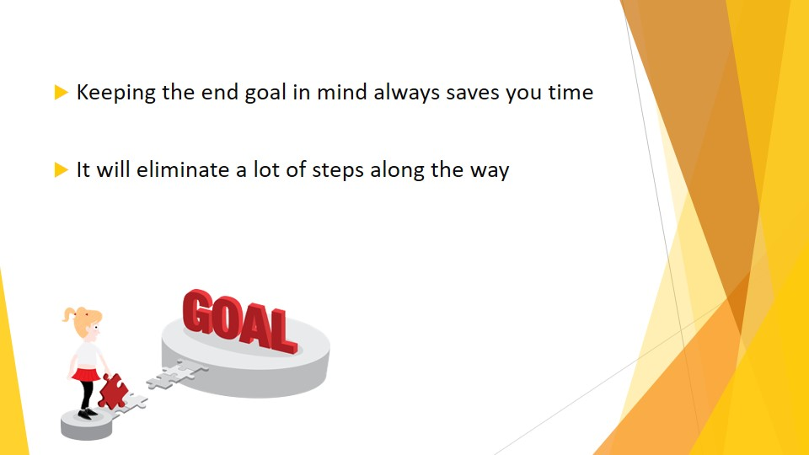
S7: Keeping the end goal in mind always saves you time. Have the necessary information at hand before you begin the actual work. It will eliminate a lot of steps along the way.

