Chapter 2: Define Your Goals


S1: In this video, we will learn how to define your goals.


S2 : Many people enjoy being busy. A day filled with random activity gives it a purpose. They become bogged down with trivial minutiae, losing sight of their priorities and totally mismanaging their productivity. Stop and think about why you begin each task before you start. Have a purpose for everything you do. That ensures that every minute of your day will be well-spent.

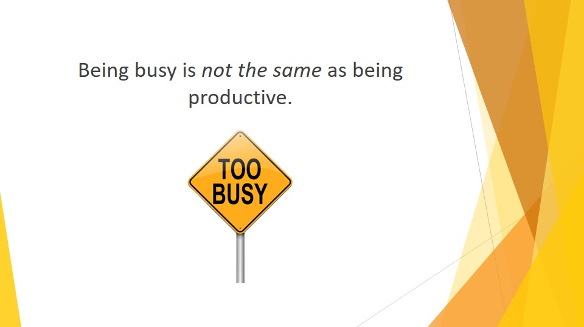
S3 : Being busy is not the same as being productive.

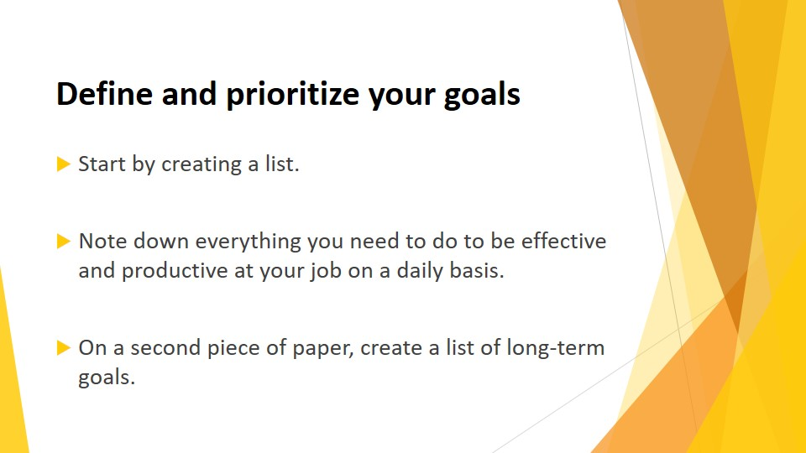
S4 : Define and prioritize your goals
Start by creating a list. Note down everything you need to do to be effective and productive at your job on a daily basis. That includes anything as mundane as filing away reports.

One of the things this list will tell you is how much time you spend in “crisis management” mode dealing with the problems of others rather than time management mode. While managing a crisis may be necessary at times, this does nothing to advance your own productivity.

On a second piece of paper, create a list of long-term goals. If your goal is to head your department within the next three to four years, what are the steps along the way?

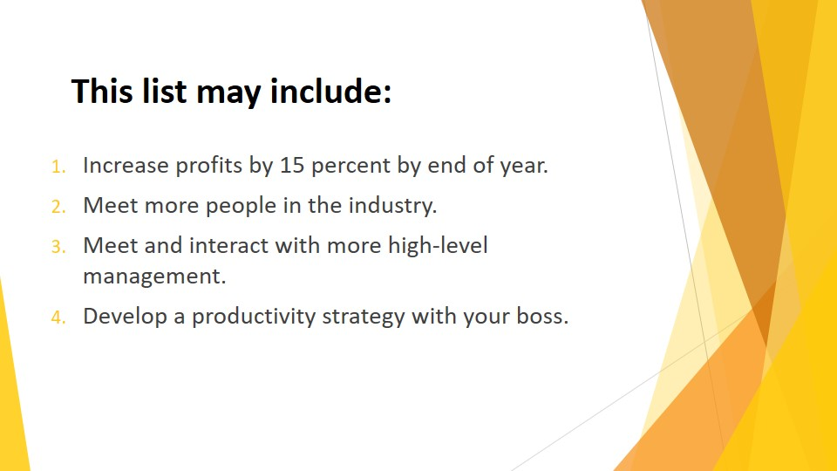
S5 : This list may include :
1. Increase profits by 15 percent by end of year.
2. Meet more people in the industry.
3. Meet and interact with more high-level management.
4. Develop a productivity strategy with your boss.

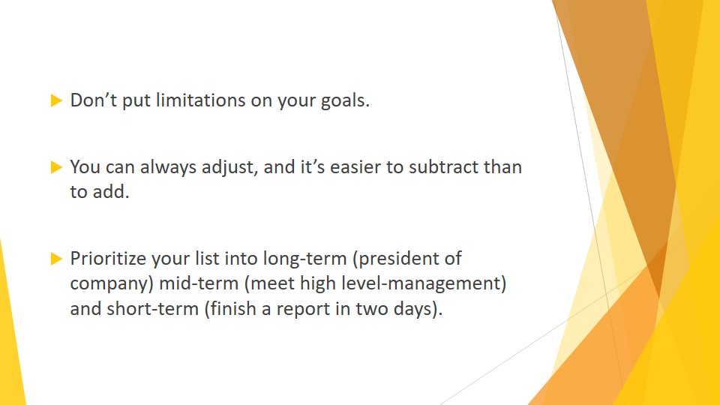
S6 : Don’t put limitations on your goals. If you’re dreaming of running the whole company someday, write it down. You can always adjust, and it’s easier to subtract than to add.
Prioritize your list into long-term (president of company) mid-term (meet high level management) and short-term (finish a report in two days).
Now, determine any and all actions necessary to reach each goal and move up the next step of the ladder. For example, what sub-steps are necessary to increase profits? A different advertising approach? Change in price schedule? A larger staff?
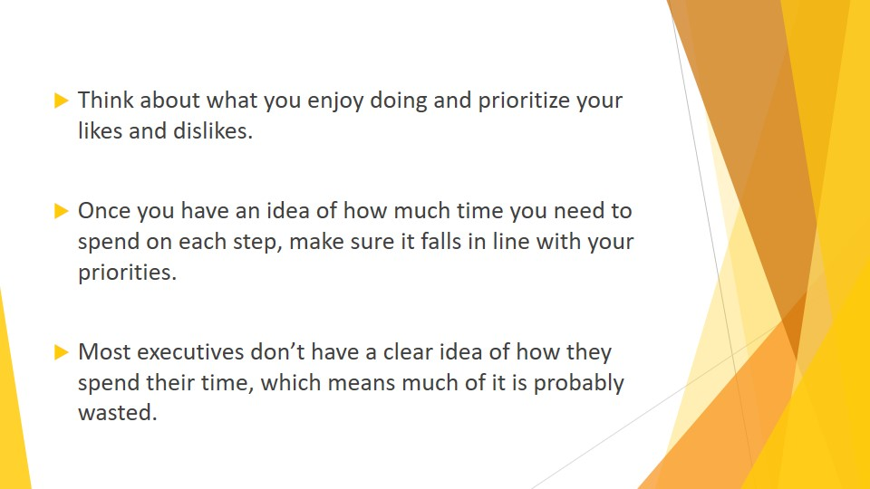
S7 : Think about what you enjoy doing and prioritize your likes and dislikes. Go back to Chapter 1 and review your strengths and weaknesses. Are you a numbers whiz? Then that should be your top priority and get the most of your time. Better adver-tising may be an intricate part of your goal, but perhaps that can be allocated to someone else, freeing up more time for you.
Once you have an idea of how much time you need to spend on each step, make sure it falls in line with your priorities. If increasing profits is your top priority, one of your steps may be to meet weekly with each salesperson for a review session. But is that a good allocation of your time, or should you institute written reports? Which way will be more productive? Most executives don’t have a clear idea of how they spend their time, which means much of it is probably wasted.

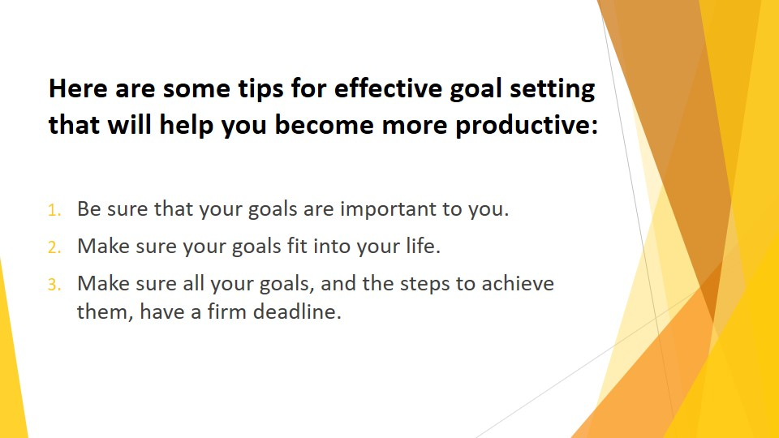
S8 : Here are some tips for effective goal setting that will help you become more productive:
1. Be sure that your goals are important to you. This may sound obvious, but it needs to be stated. We’ve already mentioned the need to get to know your-self in order to manage yourself. You may be at a job and have the normal desire to advance, but if there is no passion, you will never be fully and joy-fully productive. If you aren’t passionate about your goal list, that may indicate you are striving for the wrong goals. That’s a waste not only of time, but of your life.

2. Make sure your goals fit into your life. If you have too many goals, you will have difficulty managing the time for all of them. Time management and goals require a deep commitment. If you cannot totally commit yourself to your goals, you need to start over with your list. Ask yourself, “Why am I de-voting time to this activity? What will be the end result?” Chances are, you won’t be heading for the presidency of your company, becoming your local tennis champion, and winning the bake-off at the fair at the same time. As we have stated, time management meant making the right choices for you.

3. Make sure all your goals, and the steps to achieve them, have a firm dead-line. It’s ok to readjust to accommodate changing circumstances, but a firm plan will help keep you on track timewise.

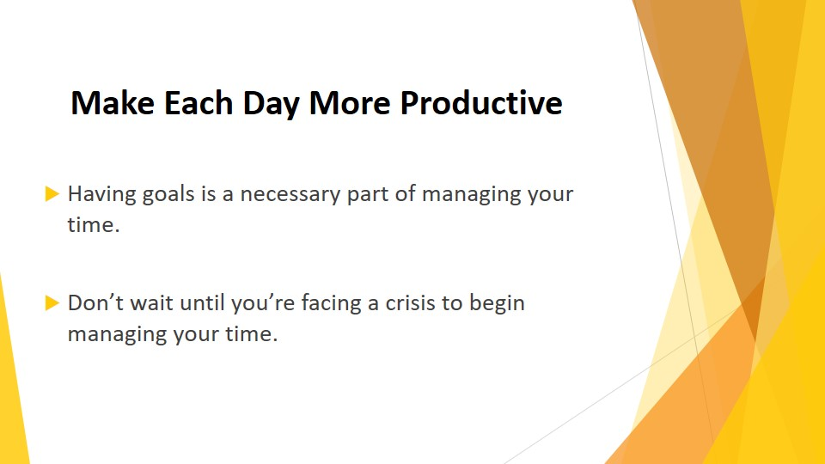S9 : Make each day more productive
Having goals is a necessary part of managing your time. But you need to take it to the next level and make sure each day is managed to the best of your ability. Don’t wait until you’re facing a crisis to begin managing your time.

S10 : Proper time management is a lifestyle and the result of your daily habits. The most productive day is a day without a crisis.

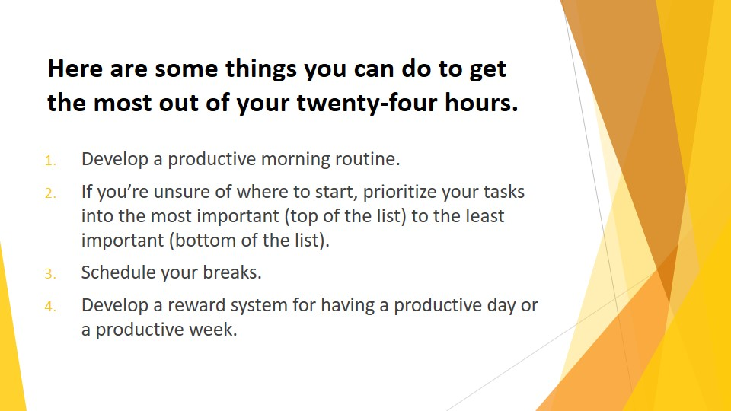
S11 : Here are some things you can do to get the most out of your twenty-four hours.
1. Develop a productive morning routine. That means getting up early enough for a good, healthy breakfast and some exercise. You are preparing yourself and your body for a productive day, so give yourself needed fuel. This might also be a good time to check your inbox (instead of throughout the day) to see want urgencies await you. Adjust your schedule (you did review your daily schedule the night before, right?) accordingly.
2. If you’re unsure of where to start, prioritize your tasks into the most important (top of the list) to the least important (bottom of the list). Getting urgent work out of the way will making routine but necessary chores easier. We have already discussed how multitasking wastes time and reduces productivity, so complete one task at a time.
3. Schedule your breaks. Breaks are not time wasters. They will give you an added boost to get more done. Taking a five-minute break every 30 to 45 minutes is perfectly reasonable. You gain back the time by being able to focus better.
4. Develop a reward system for having a productive day or a productive week. Studies indicate that 78 percent of people would be more productive if they were rewarded. Be your own rewarder. Plan treats (dinner out, time with friends, a movie) contingent on sticking to your schedule. Something as simple as a gooey dessert can be a great motivator. You need to play fair and not indulge in the treat if you didn’t produce according to plan.

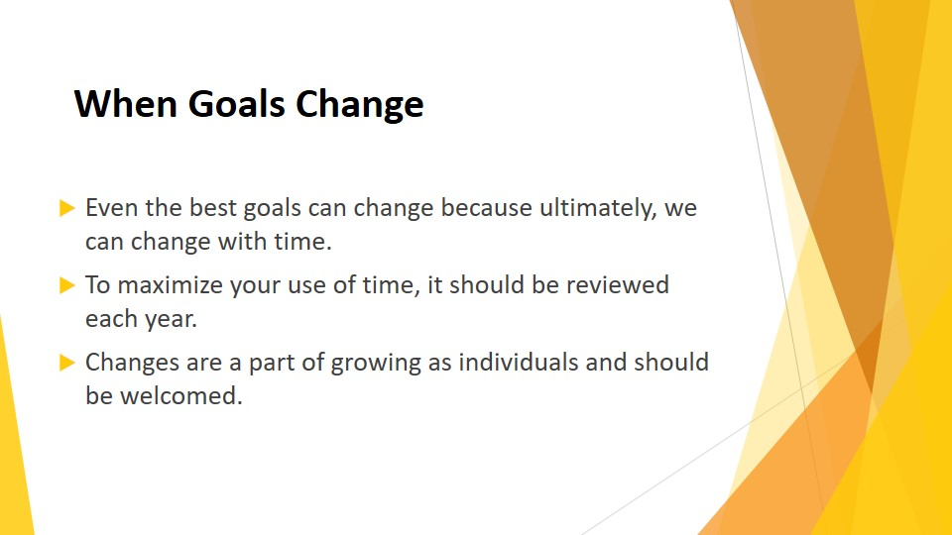
S12 : When Goals Change
Even the best goals can change because ultimately, we can change with time. What seemed like a perfect plan two years ago may no longer be the best use of our time in the present.
The journey of getting to know yourself we discussed in Chapter 1 is ongoing. To maximize your use of time, it should be reviewed each year. Changes are a part of growing as individuals and should be welcomed.

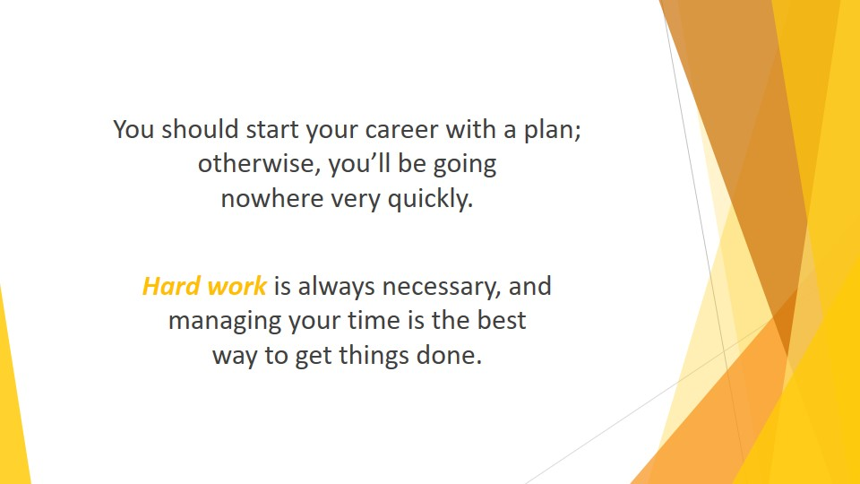
S13 : You should start your career with a plan; otherwise, you’ll be going nowhere very quickly. However, what happens when the plan no longer suits you? For example, many young law school graduates consider it a dream to beginning working for a large, prestigious firm. Making partner by age thirty-five seems like a worthy goal. After a few years, reality can hit like a sledge hammer.
Most of them end up working 12 to 16-hour days without ever seeing sunlight for at least 5 years. That’s the norm with large companies that work on a 24-hour basis. They are competing with perhaps 25 other people in the same position for that single promotion.
Hard work is always necessary, and managing your time is the best way to get things done. But regardless of how productive you are, maybe the end result starts to look a little less attractive. You work 12-hour days without seeing your family. And you start to wonder if it is worth it. You no longer manage your work; you’re simply putting in the time.

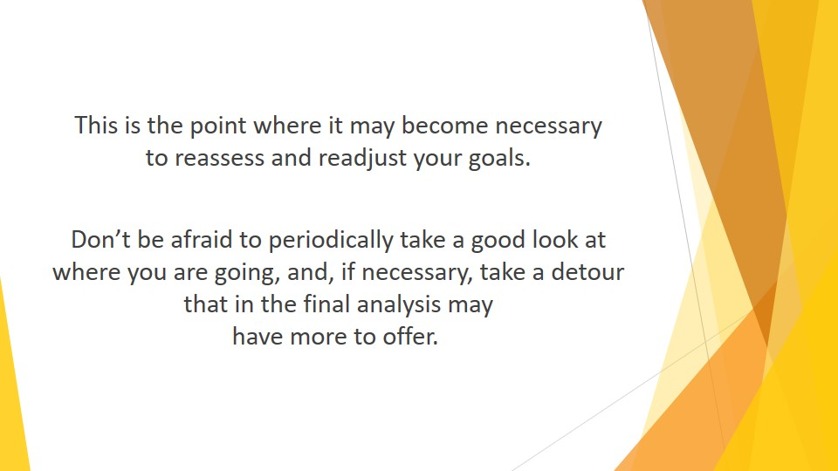
S14 : This is the point where it may become necessary to reassess and readjust your goals. While you still want your career, perhaps such a mega-environment is not the place to achieve it. Consider different paths to achieving your goal. Going out on your own and opening your own office may still involve a lot of time, but it’s time that you’ll be able to manage yourself. You get to decide what is important. This path could also provide you with more family time as your spouse spends some time at your side to help you grow.

Don’t be afraid to periodically take a good look at where you are going, and, if necessary, take a detour that in the final analysis may have more to offer. You can’t manage your time and life well unless you really enjoy the return for your efforts.

