The 5-Minute Guide to Staying Disciplined Working From Home

- SPECIAL REPORT -

By [YOUR NAME]
[URL]

Reading literature on productivity is all good and well but too often it's entirely a passive experience. That is to say that often we will nod and be impressed by all the tips we read but then don't actually follow through on any of them. Most of these productivity tips are unfortunately much too long term and take too long to have any effect… so we end up just putting them off and potentially forgetting about them entirely.

To buck that trend then, I'm going to share with you here a bunch of productivity tips that you can implement right now that will help to make your day tomorrow much more productive. If you work from home and you struggle to stay on task, then completing this guide is going to make your next working day FAR more productive.

These just take a few minutes in most cases and will make a huge difference to your day ahead… so there's no excuses!

Finishing Today's Work
Surprisingly having a productive day is often not about what you do on that day as much as it is what you do the day before to prep yourself for maximum productivity and output. If you want to be highly productive tomorrow, then you need to set your day up to be productive by taking the right steps tonight.

The first thing to do then is to finish your work today halfway through a task. The human brain likes closure, so often you will feel tempted to do whatever you can to try and complete all your tasks. In fact though, if you leave a job half-finished tonight, you'll be much more likely to want to get started right away when you return to work tomorrow. You’ll feel all “itchy” until it is finished.

What’s more, is that starting a new project is often the hardest part, and it’s resistance to that step that often leads to procrastination and wasted time. If the task is already started, then you should find it much easier to jump right back in where you left off!
Start a job for a twenty minutes or so then, and then just leave and forget about it.

Note that I am not telling you to do less work today, or to slack. The aim here is to complete whatever you would normally have finished today, but then to also make a start on tomorrows work while you’re in the zone.

And if you don’t have the option to start tomorrow’s task, then simply taking a look at what it involves so that your brain can start churning it over and mulling it through is a great strategy too.

To-Do Lists
One more thing to do before you go: write a to-do list for the next day prioritising just one or two tasks above all the others. This way when you start work you can jump straight into that to-do list without having to think about what else you should be doing.
This also has another important impact: it allows you to now forget about the tasks that are currently hanging over you, giving you that closer. Because everything that needs doing has been written down, there is no pressure to store it in your mind, which means you can let go of it and relax. We’re going to see that this is really important.

Tidy Up
Another thing you can do when you finish work before tomorrow, is to spend just a little bit of time tidying your office. This can have a huge impact on how your office makes you feel – our environments are often external representations of our current state of mind.

With a tidier office, you’ll feel more on top of things, and it will be much easier to find the things you need while working. Just 10 minutes of work tidying a night can make a big difference, and over time it will make a really big difference!

Proper Downtime
One of the biggest challenges when working from home is finding ways to separate your work time from your relaxation. Because you work and relax in the same environment, the line can become blurred. If you finish your day with more tasks to do, you might therefore be tempted to send a few emails or finish a couple of projects in the evening. You’ll probably get emails and notifications from your colleagues too.

This might seem harmless enough, but the issue is that it will prevent you from fully relaxing and unwinding. And that’s a serious problem because it means you won’t have the ability to recharge your batteries in order to return to work the next day feeling more productive and focussed.

Some ways you can ensure this don’t happen:

- Stay out of your office when you aren’t working.
- Turn off notifications on work related apps, and consider getting separate work and leisure devices.
- Avoid thinking about work when you’re not working – unless there is a project that you enjoy and you are happy to think about.
- Avoid the temptation to “just send a quick email.”
That last step can be the most difficult – especially when you find yourself worrying that you haven’t done something correctly, or you realize that you forgot something important. But many of us overestimate the importance of these kinds of tasks, and this ends up making us tired and burned out.

That then means that when you return to work tomorrow, you’ll have less energy for focussing and thinking about the work you’re doing. This means you finish less work, and it becomes a vicious cycle!

So, when you clock off tonight, make sure that you really do. That means turning off your notifications and not looking at them again until tomorrow.

Likewise, you shouldn’t go back into your office if at all possible until you next want to work. This will create an association between that office space and your productive mental state. Now, entering the office will tell your mind and body that it is “work time.”

Thinking About Tomorrow
While you should usually do your very best to switch off from thoughts of work, there are exceptions to this rule.
When you have a very big task that you are worried about completing on time, or when you have work that you are passionate about, then spending some designated amount of your downtime thinking about it can make a big difference.

If you sit down to tackle a project “cold” tomorrow, that will be MUCH harder than sitting down to tackle it with an action plan. So if you have a moment when you’re standing in a queue or driving, listening to research on YouTube, or just planning out what you’re going to do in your head can make a massive difference.

This is a concept that Cal Newport describes in his book “Deep Focus.” He calls it “productive meditation,” which is essentially a form of meditation where you focus your thoughts on solving a problem or being creative. This can make a huge difference to your work flow

The Perfect Sleep
The next important thing to focus on is your sleep and how you're going to ensure that you are getting a great quality and quantity of it. Sleep is perhaps one of the most effective 'natural nootropics' of all, meaning it can help you to boost your concentration, your alertness and your memory as well as helping your body to make repairs to any damaged tissue etc.

To prepare for the perfect night's sleep, the first thing you need to do is to avoid drinking caffeine past 4pm. On top of this you should avoid eating past 7pm and you should spend an hour before bed doing things that will help to calm you down (like reading as opposed to Call of Duty).

Take a hot shower just before bed as this will trigger a rapid cooling effect that will result in greater production of melatonin (the sleep hormone) and of growth hormone (which encourages the body to repair itself while you rest). Wearing socks can also help the body to regulate temperature.

Finally, block out any and all light in your bedroom that could cause your sleep to be more shallow or less effective. Even a little bit of light in your room can have dramatic negative impacts on the quality of your sleep, so make sure LEDs are hidden out of sight and the curtains are properly drawn. Most important of all though is to take your mobile phone out of your room. Not only are the LED indicators on mobile phones particularly bad at keeping us awake (because they share a similar wavelength to that of the sun), but also because they make it difficult for us to 'de-stress' and switch off in order to relax.

The Perfect Start to the Day
What's the ideal way to start the productive day? The first thing to do is to try and wake up when you are in REM sleep which is the lightest stage in your sleep. You can achieve this either by considering the time you went to sleep and the average length of sleep cycles, or by wearing a sleep tracking device. Many of these have “smart alarms” built in that wake us when we are in lighter sleep.

Next you should eat a good breakfast that will boost your productivity throughout the day. One good example is to eat eggs. Not only do these suppress appetite and boost your resting metabolic rate (leading to fat burning), but they contain essential amino acids that boost brain power and choline which is a precursor to one of the brain's most important neurotransmitters: acetylcholine. A complex carb is also important as the brain requires energy to run.

Many productivity gurus recommend also starting the day with a little quiet meditation in order to remove distracting thoughts and to train themselves to be better at controlling their own thought processes. Meditation is an incredibly powerful tool because it essentially means that we are practicing our ability to focus and choose what we want to pay attention to. This in turn makes it much easier to focus on work and to forget about other stressors and concerns that simply serve to pull our attention away from what we need to be doing. This has both immediate and long-term cumulative benefits.

Working out is also a great way to boost brain function and energy for the day ahead. This is especially important if you work from home, as you will be getting so much less exercise from commuting and walking around your office.
Your blood will start pumping, improving the delivery to your brain, and you will find a release of endorphins puts you in a better mood. This can also help to prevent many detrimental effects of sitting in an office all day.

Then head to your office and start having a super productive day.
Most importantly of all though: don't look at any e-mails until 12pm. As soon as you get into work you are instead going to focus on completing your to-do list and finishing that task you left from the night before.

Now you've just woken up after a particularly rejuvenating and refreshing sleep, you should find that you are particularly creative and focussed. If you then go on to answer e-mails you'll be working to someone else's agenda and you will waste some of that productivity. 99% of e-mails are not so urgent that you need to answer them right away, so instead focus on completing some real work while your brain is in optimal mode, and then check your e-mails at 12 once you've done that.

Follow these tips and you should find that tomorrow is the most productive day possible. This kind of thinking is what creates a work-from-home mindset that is conducive to productivity, and that will prevent you from falling behind and ending up stressed and overwhelmed.

TOP RECOMMENDED GUIDE:

Work From Home Productivity: Discover How To Stay Productive Working From Home and Develop Your Mind For Success
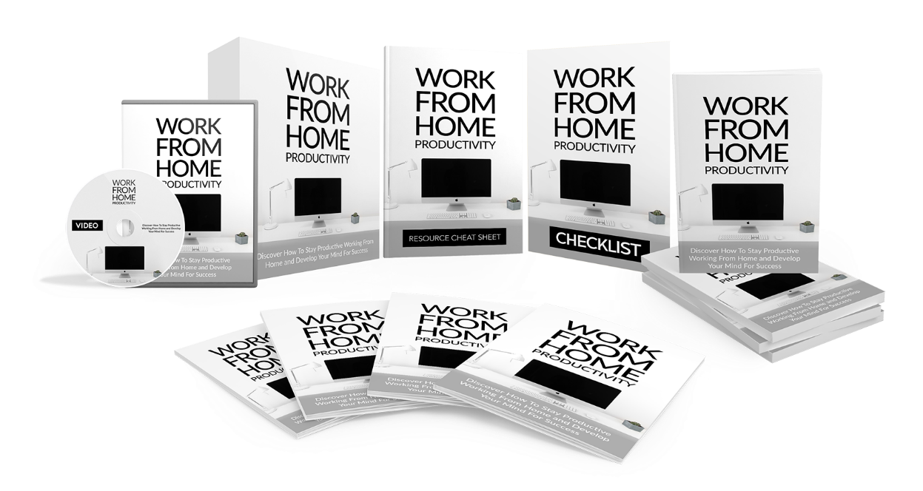

Find Out The Exact Steps And Techniques!


>> Click Here To Get Your Copy <<

